AQUAGLOSS
polyurethane water-based enamel
- exceptional toughness & elasticity
- outstanding resistance & adhesion
- excellent spreading capacity, easy to apply

Premium water-based gloss top coat based on polyurethane-modified resins. Odourless vanish, ideal for interior use. Due to its composition, this enamel also ensures excellent results on exterior surfaces. Ideal for use on metal (balustrades, steel structures, etc.) and wood (doors, door/window frames, closets, windows). Being extremely adhesive, this enamel is ideal for recoating surfaces previously painted with solvent-based enamels. Creates an elastic surface with great resistance to frequent washing/rubbing. Great coverage and hiding power, that ensure an excellent finish. This enamel is easy to apply, non splitting and has excellent spreading capacity. The velvet finish created will retain its brightness over time without yellowing.

COVERAGE
11±2m²/L

FINISH
HIGH GLOSS

THINNING
5-10% WATER

DRYING TIMES
1-2 hours*

RECOATING TIMES
4-6 hours*

RECOMMENDED NUMBER OF COATS
2-3 coats*

TOOLS
roller, brush or airless paint sprayer

* Lower temperatures or higher relative humidity will prolong drying and recoating times.

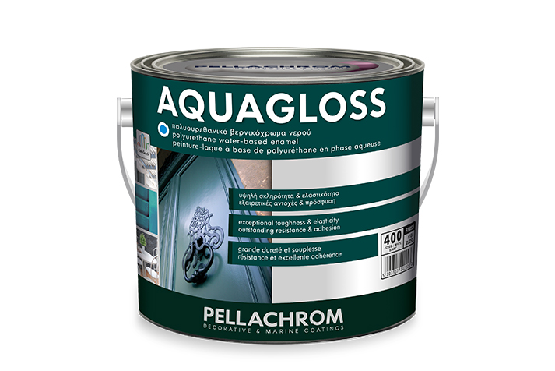

TECHNICAL CHARACTERISTICS
TYPE | POLYURETHANE-MODIFIED RESINS
SPECIFIC GRAVITY | WHITE N.400  BASE 01  BASE 02  BASE 03 | 1.24 ±0,05gr/cm³  1.22 ±0,05gr/cm³  1.12 ±0,05gr/cm³  1.07 ±0,05gr/cm³
SOLIDS w/w (ISO 3251-03) |  | 50±2 % **
SOLIDS w/v (ISO 3233-98) |  | 35±3 % **
VISCOSITY (ASTM D 562-05 @ 25⁰C) |  | KU 95±10 *
APPLICATION VISCOSITY (ASTM D 562-05 @ 25⁰C) |  | KU 75±15 *
pH |  | 7.50±0.3
HIDING POWER (ISO 3905) |  | 96% | 150μm wet film**
WHITENESS INDEX (ASTM Ε 313-05) |  | ≥ 85**
YELLOWNESS INDEX (ASTM Ε 313-05) |  | ≤ 1**
GLOSS (60⁰) (ISO 2813-99) |  | 85±2 *
GLOSS (20⁰) (ISO 2813-99) |  | 55±3 *
HARDNESS (Κönig) (ISO 1522-00) |  | 45±8 sec, after 7 days
RECOMMENDED DRY FILM THICKNESS |  | 65μm (±5μm) / 2 coats
APPLICATION TEMPERATURE |  | min 5°C-max 30°C

*differs depending on the shade.
**valid only for white.

REGULATION 2004/42/CE
EU Limit value for this product in a ready-to-use condition (cat A/d: Interior/exterior trim and cladding paints for wood and metal 130 g/L (2010). This product contains max: 129 g/L VOC.

SURFACE PREPARATION
Carefully prepare surface to obtain good results. Remove all weathered coatings, loose materials and oils. Sand and remove sanding residue with a rag.
Dust and/or hazardous fumes are generated during dry grinding or flame cutting/ welding on previously painted surfaces. Treat by wet grinding only if necessary. If local exhaust ventilation cannot minimise the exposure effects, the appropriate breathing apparatus must be used.

- New wood:
Sand and clean sanding residue. Apply putty. Apply 1-2 coats of wood preservative POLACRYL 321. Prime with AQUARUST undercoat, 1-2 coats. Apply 2-3 coats of AQUAGLOSS.
- New metal:
Sand and clean sanding residue. Apply putty. For a better antirust protection, apply 1-2 coats of AQUARUST or ANTIRUST or MARINE MINIO. Apply 2-3 coats of AQUAGLOSS.
- Smooth and stable substrate previously painted with solvent-based paints:
Sand lightly and clean sanding residue. Prime with AQUAPRIMER (wood) or AQUARUST (metal), 1 coat, depending on the type of the surface. Apply 2 coats of AQUAGLOSS.
INTENDED USE
WOOD
METAL
APPLICATION
- Stir well before and during application.
- Sand surface smooth with the right sandpaper for the task before painting.
- Do not paint when ambient temperature is below 10°C, over 30°C and humidity over 70%.
- Apply in two coats with a roller or brush and thin with WATER by 0-10%. Thin with WATER by 10-20% for application with an airless gun depending on its nozzle and the type.
- Wait for the first coat to fully harden before applying the second coat.
- Apply using a paint brush with synthetic fibres, a paint roller (preferably mohair) or a spray gun (nozzle size 1.6-1.8mm) or an airless gun spray.

USEFUL INFORMATION
- If you apply one of AQUAGLOSS shades, use a primer of the same shade.
- Tints are created exclusively using AQUAGLOSS bases in our COLORTOUCH tinting system. The addition of special COLORTOUCH COLORANTS is indispensable.
PACKAGING
- Available in White. Containers of 350ml, 750ml and 2.5L.
- AQUAGLOSS Bases (01/02/03): Available in containers of 750ml and 2.5L.
- Create thousands of different colour tints with our COLORTOUCH Tinting System. To ensure product quality, tint always the Base recommended by D.G.K. Pellachrom Tinting System.
STORAGE
2 years if unopened and stored under normal storage conditions. Once opened, seal well and store in a closed place at room temperature between 5-30°C. Keep tightly closed after application for future use. Store in a cool place. Protect against freeze and direct sunlight.
CLEAN-UP / DISPOSAL
Keep your tools wet inside the can when not painting. Rub excess paint off your tools on the side of the can after paint application. Clean tools with hot water and soap immediately after use. Do not empty washing liquids into the water table. Always handle empty containers and product carefully. Do not pour leftover product down the drain. Strictly follow local, regional, national regulations and legislation on the disposal of products and empty containers.
HEALTH & SAFETY
Read carefully the safety instructions on the label. For more information, consult the Safety Data Sheet.

